




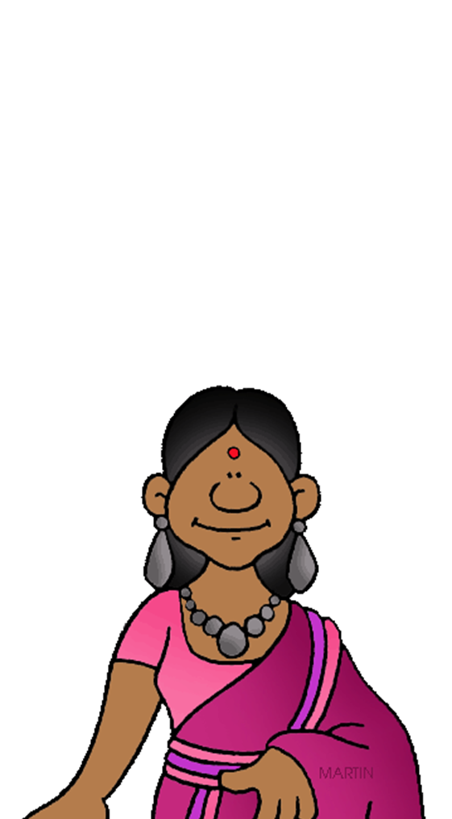





World History

Ms. Granger

Course Description
This course provides a fundamental overview of the history of humankind. The emphasis of this course will be on the study of significant persons, events, and issues from the earliest times of human civilization to the present.

Course Units
Unit 1: Ancient (Prehistory to Early Ancient)
Unit 2: Classical (Civilizations of Classical Antiquity)
Unit 3: Post-Classical (Middle Ages)
Unit 4: Early Modern (Precolumbian Americas - Age of Exploration - Renaissance)
Unit 5: Long Nineteenth Century (Age of Enlightenment - Age of Revolution - Age of Imperialism)
Unit 6: Shorty Twentieth Century (First World War - Second World War - Cold War)

Course Requirements
Materials: All students are expected to come prepared to class every day with required supplies.
- college-rule notebook paper
- black or blue pens and pencils
- colored pencils (at least a 12 pack)
- highlighter(s)
- 1” binder (or larger)
- 5 dividers (any style, any color)

Course Policies and Procedures
- Student Expectations: All students are expected to be respectful and courteous to others, their time, and property. To raise their hand to speak. To use words, hands, feet, and materials appropriately (i.e. refrain from throwing things, using profanity, writing on desks). To be on time to class with required materials. To not allow themselves to be distracted or distract others from learning.

- Electronic Devices: Students are to remove earbuds, earphones, headphones before entering the classroom, and are NOT to be used during class. Cellphones are to be silenced and placed in the classroom cellphone pouches before the bell. It is imperative that cellphones are silenced in the event of a Lockdown. Cellphones can be retrieved once class work is completed or before the end of class when indicated. No student has permission to touch anyone else’s cellphone. Each student is to retrieve their own phone. Smartwatches are also NOT to be used during class, and need to be removed for testing. The instructor will indicate to students if and when electronic devices can be used during class.

- Food and Drink: Bottled drinks are allowed, food or open drink containers are allowed in class, but subjected to lose priveledge for leaving trash/ not cleaning up after yourself.

- Seating: Students will be seated towards the front of the class. Students are to be in their seats before the bell rings (that means having already placed cellphones in the cellphone pouches). Students are to sit in their normal seat unless instructed to do otherwise. Students are to be in their seats until the bell rings at the end of class. No crowding the door.

- Classroom Cleanliness: All students are expected to clean up after themselves and dispose of trash in trashcans before being dismissed from class. Nothing is to be left on the floor or desks.

- Substitute Teachers: In the event that the instructor is absent, students are expected to follow classroom policy and procedures, and to treat the substitute teacher with the utmost respect. Treating a substitute teacher with disrespect will NOT be tolerated. Follow the substitute teacher’s instructions. Any assignment not turned in* when there is a substitute teacher will result in ZERO credit.

- Attendance: It is essential that students attend class and be on time to be successful in the course. Students need to take care of personal business on their own time. Students arriving more than five minutes late to class, even with a pass from a teacher, will be counted tardy. Students do not have permission to be late to class for another teacher. If students will be tardy, please ensure that you handle all outside business (restroom, etc.) prior to arriving to class to minimize further interruptions to the lesson. If absent, students are responsible for missed information and assignments during their absence. Students will be given the same number of days they were absent to complete missed assignments, after which the assignments will be late.

- In-Class Activities: Students will participate in a variety of in-class activities. Students will complete daily assignments, take notes, watch films, have class readings, conduct research, conduct presentations, engage in review sessions and more. Students are expected to ACTIVELY participate in class, which includes not sleeping during class. Failure to do so could result in loss of credit and privileges, such as being able to use the restroom during class.

- Assignments: All assignments are to be written in black or blue pen or pencil. All assignments are to include a student header consisting of the student’s full first and last name, the class period, and the date. Failure to follow these instructions will result in minus 10 points on each assignment. All assignments should be retained for use as study resources and in the event there is a discrepancy.

- Homework: Assigned homework is due at the beginning of class on the day indicated by the teacher. Any assignment not turned in at the beginning of class will be counted late.

- Late Assignments: The following is the late policy for on-level classes. The first day late is minus 10 points, the second day late is minus another 10 points, the third day late is minus another 10 points meaning the highest grade you can receive is a 70, and on the fourth day late the assignment is a ZERO. Major grades, by discretion.

- Exams: Students will complete exams to demonstrate their mastery of the course’s content. Students who are absent the day of an exam will be expected to take the missed quiz or exam the day they return to class. In addition, students who are absent the day of an exam may be given an alternate exam covering the same material. Students will be given a limited window to retest.

- Retesting: Students have one opportunity to retest if they score below a 75 on a test. Students are expected to attend tutorials before retesting. The highest retest grade students can obtain is a 75. Students will receive the highest of the two grades.

- Projects: Students will be assigned a variety of projects. These projects can include, but are not limited to, brochures, essays, research papers, individual or group presentations, etc. Students are expected to dress and act professionally for presentations. Projects are major grades and treated the same as tests. If a project is late, the initial grade is a zero, and the highest possible late grade is a 75.

- Academic Honesty: Concerning plagiarism, any student who submits an assignment which contains words or ideas from an existing source and is not properly credited, will be subject to full loss of credit. Plagiarism can be avoided by citing sources, which will be discussed in class. All students are expected to complete their own work. Students who engage in cheating, both the provider and recipient, will receive full loss of credit and possible further disciplinary action.

